**STATIONS OF THE CROSS**

*by Michael Raynor*

*Tonight’s ‘Stations of the Cross’ begins in the Lady Chapel.*

**Introduction and opening prayer**

Priest: In the name of the Father and of the Son and of the Holy Spirit. Amen

We walk the way of the cross in solidarity with our Lord. All too often we speak before we listen, and act without thinking first. The way of the cross can be hugely demanding, just as life makes its own demands on us. It involves us in a journey through life and death; a journey that ultimately brings us into the presence of the risen Christ. But first we must experience the pain and suffering of our Lord, as experienced by ourselves and those around us. Tonight, as we walk the way of the cross, let us listen again to our Lord, that he might show us how to transform our lives and our world with his redeeming love.

Let us pray:

Almighty and everlasting God, who in your tender love towards the human race sent your Son our Saviour Jesus Christ to take upon him our flesh and to suffer death upon the cross: grant that we may follow the example of his patience and humility, and also be made partakers of his resurrection; through Jesus Christ your Son our Lord, who is alive and reigns with you in the unity of the Holy Spirit, one God, now and for ever. **Amen.**

Let us walk with Christ the Way that leads to life.

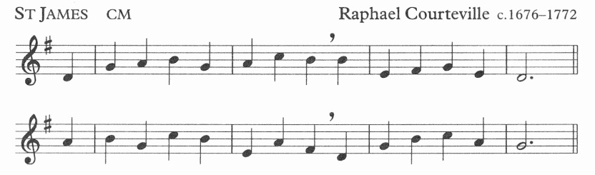

Thou art the Way: by thee alone

from sin and death we flee;

and they who would the Father seek

must seek him, Lord, by thee.

Thou art the Truth: thy word alone

true wisdom can impart;

though only canst inform the mind

and purify the heart.

# Leader 1: (1) JESUS IS CONDEMNED TO DEATH

Leader 1: We adore you, O Christ, and we bless you

All: For by your cross, you have redeemed and saved us.

Leader 2:In the garden, Jesus knew he must do his Father’s will. Though he prayed that the cup might pass him by, he accepted God’s will. Pilate was altogether different. He acted out of cowardice, not wanting to upset the mob. How easy it is to go along with the majority. How much harder to do what is right.

Leader 3: Lord Jesus

give us courage to face up to difficult decisions

and help us to do your will in all things.

Lord hear us,

**Lord, graciously hear us.**

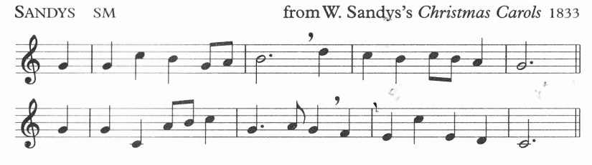

Teach me, my God and King,

In all things thee to see;

And what I do in anything

To do it as for thee.

# Leader 1: (2) JESUS TAKES UP HIS CROSS

Leader 1: We adore you, O Christ, and we bless you

All: For by your cross, you have redeemed and saved us.

Leader 2: Jesus’ whole life had come down to this one moment. Would he really be able to go through with it? And what if he couldn’t? We often fear the future. We ask ourselves whether we will be able to bear the load – of illness in someone we love; or in ourselves. We know it won’t be easy, but with our Lord beside us, all things are possible.

Leader 3: Lord Jesus

walk beside us every moment of our lives

and defend us from all that might hurt our souls

Lord hear us,

**Lord, graciously hear us.**

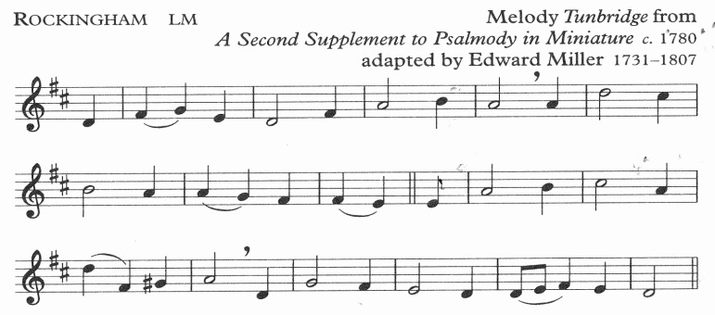

When I survey the wondrous cross

on which the prince of glory died,

my richest gain I count but loss,

and pour contempt on all my pride.

# Leader 1: (3) JESUS FALLS FOR THE FIRST TIME

Leader 1: We adore you, O Christ, and we bless you

All: For by your cross, you have redeemed and saved us.

Leader 2: What a load to bear! But it wasn’t the weight or the sharp splinters that mercilessly dug into his flesh – those things all added to the pain – but it was the shame that bore down so heavily. When we get things wrong, when we make mistakes, it is often the shame that is hardest to bear. And like our Lord, we have to summon the strength and the courage to go on.

Leader 3: Lord Jesus

defend us from our greatest fears

and give us strength to persevere

Lord hear us,

**Lord, graciously hear us.**

See from his head, his hands, his feet,

sorrow and love flow mingled down;

did e’er such love and sorrow meet,

or thorns compose so rich a crown!

# *[Rockingham p4]*

# Leader 1: (4) JESUS MEETS HIS MOTHER

Leader 1: We adore you, O Christ, and we bless you

All: For by your cross, you have redeemed and saved us.

Leader 2: The hill Jesus faced was not simply a hill, it was a colossal mountain. It needed courage far more than any mere human could muster. Jesus must have wondered whether he could do what was being asked of him. And then, out of the crowd, stepped his mother. Looking into her eyes, his strength was revitalised. He could go on. There will be times in our lives when we feel we can’t take another step – and then someone steps up and we know we’re not alone. We know we can complete the task in front of us – with their help.

Leader 3: Lord Jesus

we thank you for the love and support

of family and friends;

help us to care for them in times of need

Lord hear us,

**Lord, graciously hear us.**

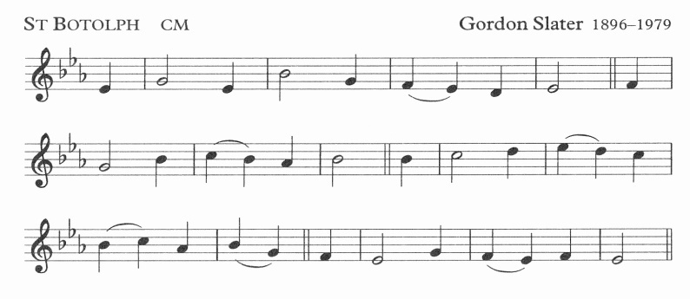

She gave her body as God’s shrine,

her heart to piercing pain;

she knew the cost of love divine,

when Jesus Christ was slain.

# Leader 1: (5) SIMON HELPS JESUS

Leader 1: We adore you, O Christ, and we bless you

All: For by your cross, you have redeemed and saved us.

Leader 2: Me? But it’s nothing to do with me! Simon must have felt hard done to when the soldier dragged him out of the crowd and made him carry Jesus’ cross. What difference would it make, anyway? He would be dead in a few hours time. Simon did help carry the cross. Without him, Jesus might never have made it to Calvary – and we might never have been saved. Sometimes we have to act, albeit reluctantly, and without ever knowing what a difference it might make.

.

Leader 3: Lord Jesus

may we never turn our back on the stranger in need;

but help them as though we are helping you

Lord hear us,

**Lord, graciously hear us.**

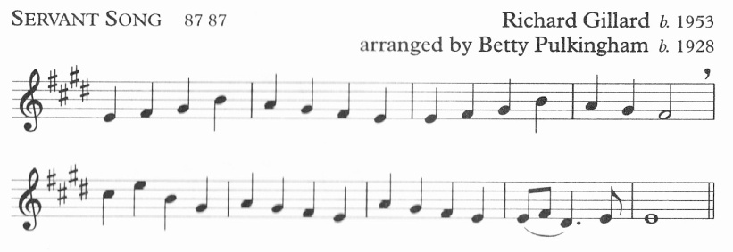

Brother, sister, let me serve you,

let me be as Christ to you,

pray that I may have the grace

to let you be my servant too.

# Leader 1: (6) VERONICA MEETS JESUS

Leader 1: We adore you, O Christ, and we bless you

All: For by your cross, you have redeemed and saved us.

Leader 2: Veronica acted instinctively. What difference could she make? In the cold light of day, you’d probably say she couldn’t make the slightest difference. But her impulsive kindness did indeed make a difference – and so can we. A prayer offered; a moment of thoughtfulness; a kind word – they may seem trivial to us, yet their enduring nature shows just how much they are valued.

Leader 3: Lord Jesus

by acts of love and kindness

may our lives reflect your love

Lord hear us,

**Lord, graciously hear us.**

I will hold the Christlight for you

in the night-time of your fear;

I will hold my hand out to you,

speak the peace you long to hear.

*[Servant Song p7]*

# Leader 1: (7) JESUS FALLS THE SECOND TIME

Leader 1: We adore you, O Christ, and we bless you

All: For by your cross, you have redeemed and saved us.

Leader 2: It’s not always our own troubles that weigh us down – often those of someone we love can be a far greater burden to carry. We may be tempted to lash out at those we feel are not helping; who are not pulling their weight. Yet lashing out does not help – it just increases our burden and that of people around us. We have to pick ourselves up when things weigh down so heavily and take the next step – one at a time

Leader 3: Lord Jesus

help us to carry one another’s cross

even when the weight seems unbearable.

Lord hear us,

**Lord, graciously hear us.**

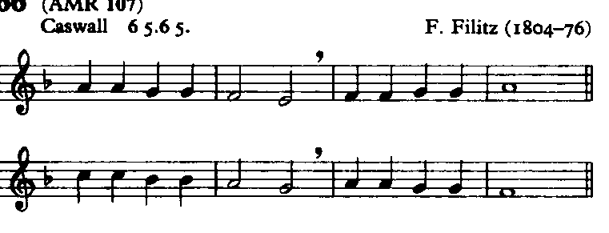

Glory be to Jesus,

who, in bitter pains,

poured for me the life-blood

from his sacred veins.

# Leader 1: (8) JESUS COMFORTS THE WOMEN OF JERUSALEM

Leader 1: We adore you, O Christ, and we bless you

All: For by your cross, you have redeemed and saved us.

Leader 2: Why did they weep? Was it for Jesus, or did they imagine their own children having to bear heavy burdens in their own lives. Did they see these things through the eyes of Mary, through the eyes of every mother that ever lived? Pain can make a person inward-looking and full of self-pity. In his pain and suffering, Jesus found time to look beyond himself and comfort them. Could we do the same?

Leader 3: Lord Jesus

may we never feel self-pity in our lives

but look to serve the needs of your world.

Lord hear us,

**Lord, graciously hear us.**

I will weep when you are weeping;

when you laugh, I’ll laugh with you.

I will share your joy and sorrow

till we’ve seen this journey through.

*[Servant Song p7]*

# Leader 1: (9) JESUS FALLS THE THIRD TIME

Leader 1: We adore you, O Christ, and we bless you

All: For by your cross, you have redeemed and saved us.

Leader 2: Sometimes we fall when we make the wrong choice; when we put ourselves and our interests first without thinking about others. Sometimes we fall through no fault of our own. But the result is exactly the same. We fall under a weight that seems too great to bear. Yet as we pick ourselves up, as we make amends for our greed and selfishness, we take the first step forward that may well make us better people – better because of the fall we’ve experienced.

.

Leader 3: Lord Jesus

teach us to learn from our mistakes

and grow in grace and goodness

Lord hear us,

**Lord, graciously hear us.**

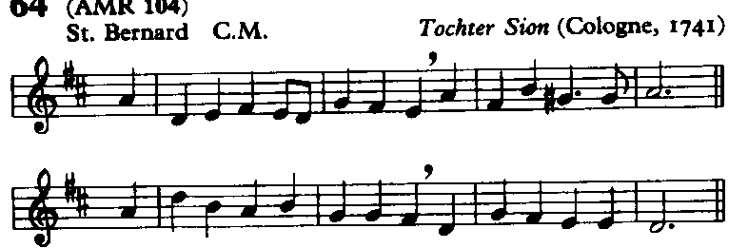

Ye hear how kindly he invites;

ye hear his words so blest:

‘All ye that labour come to me,

and I will give you rest.

# Leader 1: (10) JESUS IS STRIPPED

Leader 1: We adore you, O Christ, and we bless you

All: For by your cross, you have redeemed and saved us.

Leader 2: The soldiers strip away the last vestiges of his dignity. Not that Jesus chose to hide his true identity, even when it made him unpopular. The fact is that we try to hide our true selves all the time, often trying to be something or someone we are not. And how it hurts when someone strips away that protective shell.

Leader 3: Lord Jesus

you made us in your image;

may we never be ashamed of who we are

and may our lives reflect your love

Lord hear us,

**Lord, graciously hear us.**

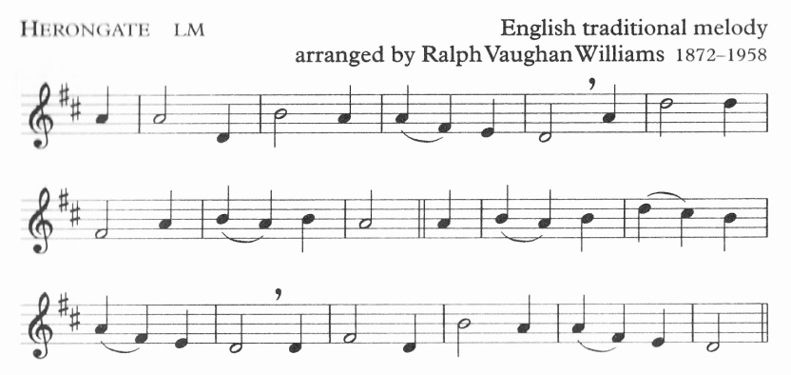

I sometimes think about the cross,

and shut my eyes and try to see

the cruel nails and crown of thorns,

and Jesus crucified for me.

# Leader 1: (11) JESUS IS NAILED TO THE CROSS

Leader 1: We adore you, O Christ, and we bless you

All: For by your cross, you have redeemed and saved us.

Leader 2: Brutally, the soldiers nail Jesus to the Cross. First his arms, and then his feet. It gives the illusion that he can still move, taking the weight off his arms, and then his legs, but in reality, he is fixed. How often we feel trapped by life – apparently free to do as we please, but in reality, constrained by people or events.

Leader 3: Lord Jesus

we pray for all who suffer in our world;

help us to speak up on their behalf.

Lord hear us,

**Lord, graciously hear us.**

See from his head, his hands, his feet,

sorrow and love flow mingled down;

did e’er such love and sorrow meet,

or thorns compose so rich a crown!

*[Rockingham p4]*

# Leader 1: (12) JESUS SPEAKS TO HIS MOTHER

Leader 1: We adore you, O Christ, and we bless you

All: For by your cross, you have redeemed and saved us.

Leader 2: Mary’s Son – in agony, nailed to a cross. How could she possibly stand there? How could she possibly not? It was an agonising choice – and also a foregone conclusion. Motherly love determined that she must be there. When someone we love is in trouble would we not do the same, no matter what the cost?

Leader 3: Lord Jesus

when other people need us

may we never be found wanting or missing

Lord hear us,

**Lord, graciously hear us.**

I cannot tell how he could love

a child so weak and full of sin;

his love must be most wonderful,

if he could die my love to win.

*[Herongate p11]*

# Leader 1: (13) JESUS DIES ON THE CROSS

Leader 1: We adore you, O Christ, and we bless you

All: For by your cross, you have redeemed and saved us.

Leader 2: Death strips us of everything We can no longer exert influence of any kind – or can we? Jesus’ death is at the heart of the gospel and represents the ultimate victory. Had Jesus not died, we might never have heard of him again. But die he did – and we live in the light of this victory. It prompts us to ask what we can do in our lives that will leave a lasting legacy for those we love.

.Leader 3: Lord Jesus

may our lives enrich the lives of those around us

by deeds of love and kindness.

Lord hear us,

**Lord, graciously hear us**

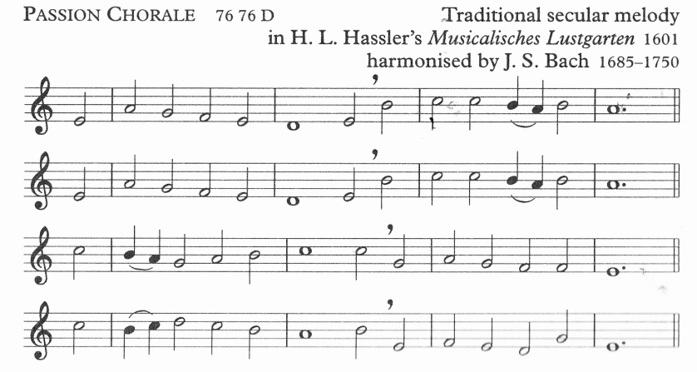

O S

a

O sacred head, surrounded

by crown of piercing thorn!

O bleeding head, so wounded,

so shamed and put to scorn!

Death’s pallid hue comes o’er thee,

the glow of life decays;

yet angel-hosts adore thee,

and tremble as they gaze.

# Leader 1: (14) JESUS IS TAKEN DOWN FROM THE CROSS

Leader 1: We adore you, O Christ, and we bless you

All: For by your cross, you have redeemed and saved us.

Leader 2: In death, as in life, Jesus is not alone. Joseph of Arimathea went to Pilate to ask that Jesus’ body might be lifted down for burial, and when it was, Mary, who had cradled him as a baby, cradled him again in death. Sometimes we overlook those who try to help us. We need to be more aware of the love that surrounds each one of us because they point to the love that the Father has for each one of us.

Leader 3: Lord Jesus

help us to know that we are never alone.

May we seek out the lost and enfold them in your love.

Lord hear us,

**Lord, graciously hear us**

In this thy bitter passion,

good Shepherd, think of me

with thy most sweet compassion,

unworthy though I be:

beneath thy cross abiding

for ever would I rest,

in thy dear love confiding,

and with thy presence blest.

# Leader 1: (15) JESUS IS TAKEN LAID IN THE TOMB

Leader 1: We adore you, O Christ, and we bless you

All: For by your cross, you have redeemed and saved us.

Leader 2: There is an apparent finality in burial. For Mary and the disciples, their dreams had been shattered, their hopes dashed. How wrong they were! We know that this wasn’t the end, but rather that it was the beginning. The beginning of life which never comes to an end, of hope founded and rooted in God. This was a necessary first step that leads to eternal life. It was not the end – it was the beginning.

Leader 3: Lord Jesus

your resurrection brought life to the world;

Fill your creation with hope and confidence

in your new life.

Lord hear us,

**Lord, graciously hear us**

*Everyone returns to their place in the Lady Chapel:*



Oft as earth exulting

wafts its praise on high,

angel-hosts rejoicing

make their glad reply.

Lift ye then your voices;

swell the mighty flood;

louder still and louder

praise the precious blood.

Priest: Through the cross you brought joy into the world

All: We worship you Lord, we venerate your cross, we praise your glorious resurrection.

***If the Eucharist follows:***

Priest: The risen Christ came and stood among the disciples and said, “Peace be with you”. Then they were glad when they saw the Lord. The peace of the Lord be always with you.

**All: And also with you**

Priest: Let us offer one another a sign of peace.

The Eucharist continues with the Eucharistic Prayer.

***If there is no Eucharist:***

Leader 3: Lord Jesus, ever-present in our lives; inspire us with your love, strengthen us in your service and fill our hearts with love for your creation. **Amen**

Priest: Christ give us grace to grow in holiness, to deny ourselves, take up our cross, and follow him; and the blessing of God almighty, the Father, the Son and the Holy Spirit, be among us and remain with us always. **Amen**

*We remain kneeling for the final hymn*

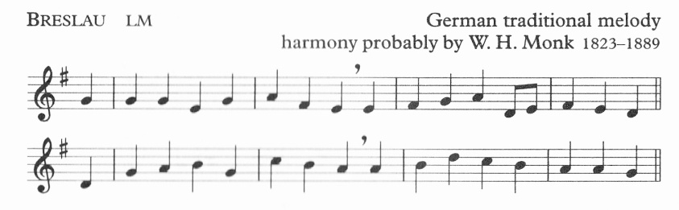

#

Take up thy cross, the Saviour said,

if thou wouldst my disciple be;

deny thyself, the world forsake,

and humbly follow after me.

To thee, great Lord, the One in Three,

all praise for evermore ascend:

O grant us in our home to see

the heavenly life that knows no end.